High-Level Techno-Functional Design Specification
  - Autonomous Proposal Document Creator for IT Solutions

Executive Summary
This document presents a high-level techno-functional architecture for an Agentic AI application — the Autonomous Proposal Document Creator for IT Solutions — designed to accelerate PwC's pre-sales and bid lifecycle.
The agent ingests client artefacts (RFI/RFP, project timeline, competency documents, company asset lists, questionnaires, and financial documents), analyses them against the organization's capabilities and financial constraints, and autonomously produces a client-presentable draft proposal deck (PowerPoint) containing a high-level solution approach, landscape architecture, program timeline, resource distribution, and required skills.
The architecture follows the Agentic Design Philosophy: "AI agents are not merely LLM calls — they are distributed software systems built around reasoning engines, context management, memory systems, tool ecosystems, and governance frameworks." The deck is rendered deterministically from a structured JSON intermediate representation (not directly by an LLM), ensuring brand consistency. The output is always a draft requiring human review — never auto-finalized.

Solution Overview & Design Principles

Design Principles Aligned to Best Practices
# | Principle | Application to Proposal Creator
1 | Context is King | Context engineering across RFP, competency, asset & financial docs — not just prompting
2 | System Prompts are Architecture | Each agent has a role definition, capability boundaries, output schema, and embedded guardrails
3 | Agent Loop as Control System | Observe → Reason → Plan → Act → Evaluate → Update Memory cycle for proposal generation
4 | Plan-and-Execute Reasoning | Best for this structured workflow (ingest → analyse → design → plan → assemble → render)
5 | Design for Multi-Agent from Day One | Specialist sub-agents under a hierarchical orchestrator
6 | Guardrails are Load-Bearing Walls | All five rail types implemented; never fabricate capabilities/assets
7 | Evals are the Test Suite | LLM-as-judge + golden dataset of approved/winning proposals

Agent Category Classification
The application spans two categories:
- Generative/Advisory Agent — Produces solution design, architecture, timeline, and resourcing recommendations.
- Document Generation Agent — Renders a brand-compliant PowerPoint deliverable deterministically.

Functional Design

Business Objective
Reduce proposal turnaround from days to hours by automating first-draft creation of IT solution proposal decks, while ensuring recommendations reflect actual organizational competencies, assets, and financial constraints.

Key User Personas & Interactions
Persona | Interaction
Pre-Sales / Solution Architect | Uploads RFP set; reviews & refines generated draft
Bid / Proposal Manager | Ensures RFP-coverage, consistency, brand compliance
Delivery Lead | Validates timeline, resource loading, skill mapping
Reviewing Partner | Approves evidence-backed content for client release

Expected Inputs and Outputs
Inputs: RFI/RFP, project duration/timeline, competency document, company asset list, questionnaire, financial document. Output: Draft PowerPoint proposal deck — Solution Approach, Landscape Architecture, Project Duration, Resource Distribution, Skills Required.

Functional Flow (Step-by-Step)
- User uploads RFP + supporting documents via portal.
- Documents parsed, classified, chunked into structured data.
- Requirements mapped against assets & competencies (RAG-grounded); gaps flagged.
- Solution approach + landscape architecture generated.
- Timeline, resource distribution & skill matrix derived from scope + financials.
- Content compiled into structured JSON intermediate representation.
- Deterministic tool renders the PPT deck.
- Human review, edit, and approval.

Agent Design (B)

Single-Agent vs. Multi-Agent Justification
A Hierarchical Orchestrator with Sequential/Parallel Sub-Pipelines is selected. The task has distinct specialist functions (parsing, requirement mapping, solution design, planning, rendering) requiring different reasoning frameworks and model tiers. A single agent would suffer context overload and tool confusion. Design for multi-agent from day one.

Agent Roles & Responsibilities

Agent 1 — Orchestrator (Manager)
Attribute | Details
Role | Central coordinator; delegates to specialist agents, handles errors & HITL escalation
Reasoning | Plan-and-Execute
Context Isolation | Passes only required context to each sub-agent (least-privilege)
Model Tier | Frontier-class (open-source 405B-class or via gateway)

Agent 2 — Document Intake & Processing Agent
Attribute | Details
Role | Ingests, parses, classifies & chunks RFP/competency/asset/financial docs
Reasoning | ReAct (dynamic tool selection)
Output | Structured JSON: chunks, metadata, entity tags (requirements, constraints, budget)
Model Tier | Small/cheap model

Agent 3 — Requirement Analysis & Knowledge Agent
Attribute | Details
Role | Maps client requirements ↔ organizational assets & competencies; gap analysis
Reasoning | ReAct + RAG
Model Tier | Mid-tier

Agent 4 — Solution Design Agent
Attribute | Details
Role | Generates solution approach + landscape architecture
Reasoning | Tree-of-Thoughts (multiple valid architectural options)
Model Tier | Frontier-class

Agent 5 — Planning & Estimation Agent
Attribute | Details
Role | Derives timeline, resource distribution, skill matrix from scope + financials
Reasoning | Plan-and-Execute
Model Tier | Mid-tier

Agent 6 — Proposal Assembly Agent
Attribute | Details
Role | Compiles & quality-reviews narrative; emits final structured JSON IR
Reasoning | Reflexion (quality-critical drafting)
Model Tier | Frontier-class

Orchestration Logic
Sequential pipeline within hierarchical control: Intake → Requirement Analysis → (Solution Design ∥ Planning — parallel fan-out) → Assembly → Deterministic Render.

Decision Points & Autonomy Boundaries
- Decision points: missing/ambiguous inputs → escalate; low solution-fit confidence → flag; budget exceeded → re-plan loop.
- Autonomous: parsing, analysis, draft generation.
- Human-in-the-loop (mandatory): all client-facing output and financial commitments. The agent produces a draft only.

Architectural Design

High-Level Architecture
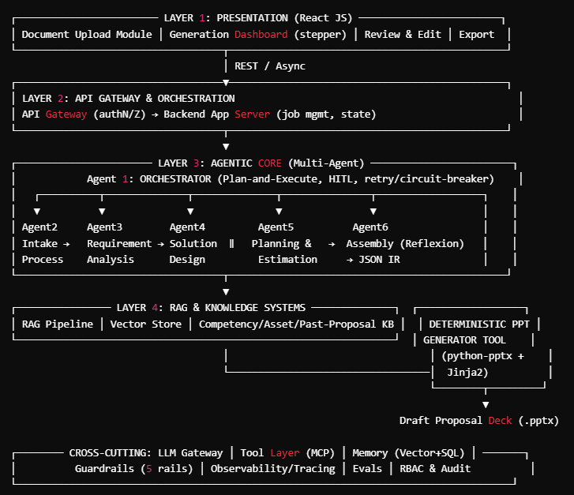

Core Components & Responsibilities
- Presentation Layer: upload, real-time progress stepper (Ingesting → Analyzing → Designing → Planning → Assembling → Complete), review/edit, download.
- API Gateway & Orchestration: auth, job tracking, session state, async coordination.
- Agentic Core: the six specialist agents executing the runtime loop.
- RAG & Knowledge Layer: semantic retrieval of competencies, assets, reference architectures, past proposals.
- Deterministic Generator: renders the deck from JSON IR for pixel-perfect, brand-compliant output.

Data Flow & Control Flow
- Control: synchronous for user interaction; asynchronous (event-driven) for long-running agent processing.
- Data: raw docs → structured JSON (chunks/entities) → grounded analysis → solution+plan JSON → assembled JSON IR → .pptx artefact.

AI & LLM Design

Choice of LLMs (Open-Source Preferred)
Task | Model Tier
Parsing / extraction | Small open model (Llama 3.1 8B / Mistral)
Requirement mapping & planning | Mid-tier open (Llama 3.1 70B / Qwen)
Solution design & assembly | Frontier-class open (Llama 3.1 405B / Mixtral) or pluggable proprietary via gateway

LLM Call Patterns
- Prompting: system prompts as behavioral spec (role, boundaries, output schema, guardrails).
- Tools: schema-driven function calling (parsers, estimation calculators, PPT generator).
- Memory: three-tier — episodic (past proposals), semantic (org knowledge), procedural (workflow patterns).

RAG Approach — Required (Yes)
- Rationale: Output must be grounded in organization-specific assets, competencies, and prior proposals to prevent hallucinated capabilities/architectures.
- Data Sources: competency documents, asset inventory, prior winning proposals, reference architecture library, rate cards.

Data & Integration
System / Connector | Purpose | Nature
Object / Document Store | Store uploaded docs & generated decks | Read/Write, Async
Vector DB (Qdrant / Weaviate) | Semantic retrieval | Read-heavy, Sync
Relational DB (PostgreSQL) | Session state, episodic logs, job tracking | Read/Write, Sync
Knowledge Graph (Neo4j, optional) | Skill ↔ resource ↔ asset modeling | Read, Sync
HR / Resourcing API (optional) | Live competency & availability | Read, Sync/Async
Finance / Rate-Card source | Costing & financial validation | Read, Sync
Document Parsing / OCR Service | Extract text from PDFs/scans | Read, Sync

Frameworks & Tooling
Layer | Recommendation (Open-Source First)
Agent Orchestration | LangGraph (stateful hierarchical/graph workflows); alt: CrewAI, AutoGen
Tool Protocol | MCP for plug-and-play tool/data connectivity
RAG / Retrieval | LlamaIndex / LangChain retrievers; semantic chunking
Vector Store | Qdrant / Weaviate
Memory | Vector (semantic) + PostgreSQL (episodic) + summarization-based short-term
Document Generation | python-pptx (deterministic) + Jinja2 (data binding)
Observability | OpenTelemetry + Langfuse/LangSmith; trace every tool call (inputs, outputs, latency, status)
Evaluation | Offline evals + LLM-as-judge against golden proposal dataset

Dependencies & Constraints

External Dependencies
- LLM inference (self-hosted open-source or via gateway).
- Document parsing/OCR service.
- Optional HR/resourcing and finance integrations.

Assumptions
- Cloud-agnostic, containerized deployment.
- Input documents reasonably complete and machine-readable.

Known Limitations
- Output is a draft requiring human review — never auto-finalized.
- Recommendation quality bounded by freshness/quality of organizational knowledge in the RAG store.

Guardrails (Five Rail Types)
Rail | Application
Input | Validate doc types; PII detection/redaction
Dialog | Keep scope to proposal generation; out-of-scope detection
Retrieval | Source-grounding; only cite verified assets/competencies
Execution | Tool timeouts, circuit breakers, idempotency
Output | Brand-compliance, factual grounding, confidence flagging

Security & Compliance (High-Level)
- RBAC + audit trails; encryption at rest/in transit; data minimization.
- GDPR alignment (right-to-erasure on memory stores).
- AI transparency: outputs marked as AI-generated drafts.

End-to-End Workflow
Proposal Generation Flow: Upload → Intake/Parse → Requirement Analysis (RAG) → [Solution Design ∥ Planning] → Assembly (Reflexion) → JSON IR → Deterministic PPT Render → Human Review & Approve → Export.

